Detecting Regime Shifts in the Dhaka Stock Exchange Using LSTM Autoencoders and Eigenvector Dynamics
Table of Contents
1 Introduction 1
1.1 Background 1
1.2 Problem Statement 2
1.3 Current Research Limitations 2
1.4 Rationale for the Study 3
1.5 Aims and Objectives 4
2 Literature Review 4
3 Dataset Formation 6
3.1 Dataset Description 6
3.2 Dataset Segmentation 7
4 Methodology 7
4.1 Normalized Logarithmic Return 7
4.2 Model Construction 8
4.3 Model Training 11
4.4 Weight Matrix Formation 11
5 Expected Outcomes 12
6 Conclusion 12
7 References 13

List of Figures and Tables
Figure No. | Title | Page No.
Figure 1 | Dataset preparation from the stock returns in a year j for model training. | 7
Figure 2 | Architecture of an LSTM unit, illustrating the flow of information through the input gate, forget gate, and output gate. | 9
Figure 3 | Comprehensive overview of the proposed LSTM Autoencoder architecture. | 10

Table No. | Title | Page No.
Table 1 | Distribution of Sampled DSE Companies by Sector | 6

Introduction

Background
Financial markets are naturally dynamic and complex systems influenced by the interactions of diverse agents, including individual investors, institutional traders, financial intermediaries, and regulatory authorities [1], [2]. These actors function with diverse aims and risk appetites, establishing complex feedback processes that influence price fluctuations, market liquidity, and overall volatility. Market systems, intended to promote stability and efficiency, are susceptible to several factors, including macroeconomic shocks, geopolitical events, policy alterations, and endogenous systemic risks, which may result in both incremental adjustments and abrupt disruptions [3]. One of the most significant phenomena in such systems is the occurrence of regime shifts, or critical transitions, which refer to abrupt and fundamental changes in the underlying statistical behavior of asset prices [4]. These shifts often manifest as transitions between bull and bear markets, or from stable to highly volatile conditions. Unlike ordinary fluctuations, regime shifts represents deep structural changes that alter return distributions, volatility clustering, and asset correlations [5]. Recognizing the early signs of such transitions is crucial for investor and risk manager to protect portfolios, reallocate assets, and prevent systemic losses.

Conventional econometric methods, including Markov-switching and GARCH-family models, have been employed to identify these transitions. However, their reliance on linear assumptions and rigid structures limits their effectiveness when confronted with nonlinear, nonstationary, and high dimensional market data. As financial systems get progressively high-dimensional, encompassing hundreds of interconnected assets, there is a must for more adaptable and data-driven approaches. Recent breakthroughs in machine learning, particularly deep learning techniques like Long Short-Term Memory (LSTM) networks, have offered new paths for evaluating financial time series. LSTMs are well-suited for capturing long-range temporal dependencies and nonlinear patterns, making them excellent for modeling developing market dynamics with an autoencoder framework. LSTMs may learn latent representations of multivariate time series, allowing for the discovery of structural anomalies that may provide early warning signs of regime transitions [6]. Alongside temporal modeling, eigenvector dynamics derived from the spectral decomposition of correlation or covariance matrices offer vital insights into the structural structure of the market. Monitoring changes in the primary eigenvectors (or dominant market modes) can reveal sectoral dominance, or market coherence [7]. Rapid changes in the eigenvector orientation or magnitude have often been linked to upcoming market swings or instability.

By integrating these two perspectives—deep learning for temporal dynamics and eigenvector analysis for structural understanding—offers a promising strategy for robust and interpretable regime shift identification. In this research, we apply this particular approach to the Dhaka Stock Exchange (DSE), an emerging market characterized by unique volatility patterns and limited prior research. Through this work, we aim to contribute to improve risk management and informed decision making in complex financial environments.

Problem Statement
Accurate and timely identification of regime transitions in financial markets remains a critical task due to the complex, nonlinear, and non-stationary character of asset price dynamics. Although a variety of statistical, econometric, and machine-learning approaches have been developed to discover early warning signals, no unified framework currently exists that successfully integrates temporal anomaly detection with structural insights from inter-asset linkages. In particular, while LSTM autoencoders are capable of uncovering temporal deviations by detecting elevated reconstruction errors, and eigenvalue decomposition (ED) of similarity or correlation matrices can reveal shifts in dominant market modes. These methodologies have rarely been integrated within a single, large-scale framework. As a result, their potential for jointly detecting and interpreting regime shifts remain unexplored. This gap is relevant for emerging market such as the Dhaka Stock Exchange (DSE). DSE is characterized by high volatility, relatively low liquidity, and strong sensitivity to policy and regulatory changes. Yet, unlike developed markets, DSE has received limited academic attention. Again traditional approaches have often failed in such high volatile market to capture its nonlinear and high dimensional characteristics.

Consequently, it remains unclear whether a hybrid framework, integrating LSTM autoencoders and eigenvector dynamics can reliably pinpoint pre-crash tipping points and regime transition in the DSE during crises such as the European Sovereign Debt crisis (2011), the global decline (2015), and the COVID–19 crash (2020), and Russia –Ukraine war (2022).

Current Research Limitations
Various strategies have been developed to detect financial market shifts, but each has drawbacks. ARCH/GARCH models are extensively utilized but tend to be unstable during volatile times and rely on assumptions about noise distributions that may not hold true [8], [9]. Random Matrix Theory and eigenvalue decomposition give insight into market structure by studying correlations but only capture linear interactions, possibly missing key nonlinear dynamics [10]–[13]. Principal Component Analysis, widely employed with these methodologies, has similar limitations and may ignore early symptoms of crises [14]–[17]. Advanced approaches like mutual information and transfer entropy better capture nonlinear and directional dependencies but encounter limitations in real-time multivariate analysis [18]–[20]. Copula models illustrate reliance across markets but presume steady linkages, making them less useful for unexpected shifts [21], [22].

Machine learning methods, such Random Forest and gradient boosting, may anticipate volatility and identify regime shifts but generally require independent data points, which is impractical during crises, resulting to lower accuracy [23]–[27]. Clustering approaches reveal risk regimes but lack temporal modeling and structural interpretation [25], [26].

Deep learning models, notably LSTM autoencoders, have shown promise in learning complex temporal patterns and detecting anomalies via reconstruction errors. Yet, most studies focus on narrow datasets and developed markets, leaving their applicability in emerging markets like Dhaka Stock Exchange (DSE) largely unexplored [28]–[32].
Currently, no integrated framework exists that combines LSTM-based temporal modeling with eigenvalue decomposition of similarity matrices to effectively detect regime transitions in emerging market while accounting their unique volatility and structural sensitivity. This gap highlights the need for a hybrid approach that is capable of jointly capturing temporal anomalies and structural shifts in Dhaka Stock Exchange (DSE).

Rationale for the Study
To mitigate the limitations of existing methods, we propose a hybrid approach that combines LSTM autoencoders with eigenvalue analysis to detect regime shifts in financial markets, specifically the Dhaka Stock Exchange (DSE). The DSE, as an emerging market, exhibits high volatility, low liquidity, and sensitivity to policy and regularity changes, making it an ideal context. We start by calculating normalized daily log returns for 210 components of the Dhaka Stock Exchange (DSE) index from January 1, 2010, to December 31, 2024, dividing the data into 15 annual periods. Each year is further split into overlapping five-day windows to capture short-term trends effectively. For every year, we train a custom five-layer LSTM autoencoder consisting of two stacked LSTM layers as the encoder, a central dense (fully connected) bottleneck layer, and two LSTM layers as the decoder. The model takes in five-day windows of normalized returns for all stocks, learning temporal dependencies and compressing the information into a low-dimensional feature vector. This vector passes through the dense layer, whose encode the inter-stock relationships, before the decoder reconstructs the original input sequence. Essentially, to reconstruct a target stock’s returns, the autoencoder draws information from every other stock within the same five-day window.

After training the LSTM autoencoder for each year, we extract the absolute values of the dense layer’s weights, which effectively encode the relationships between stocks, and organize them into a year-specific weight matrix. Using these matrices, we compute similarity matrix by calculating pairwise L₁ distances between the normalized weight vectors, followed by normalization of the similarity scores to a standardized range between 0 and 1. We then perform eigenvalue decomposition on this similarity matrix to obtain the leading eigenvectors, which capture the dominant modes of variation in market structure. The temporal evolution of these eigenvectors reflects underlying structural shifts in the Dhaka Stock Exchange. Finally, we validate the effectiveness of this hybrid approach by comparing detected market-state changes with historical periods of market stress in the DSE including notable crashes and periods of heightened volatility.

By applying the method to a series of major market declines, including the European Sovereign Debt Crisis (2011), the global market decline (2015), and the COVID-19 crash (2020), and Russia-Ukraine war(2022), we hope to test whether combined LSTM autoencoder-derived inter-stock similarity and eigenvalue-based clustering can serve as an efficient early-warning indicator for emerging market specifically the Dhaka Stock Exchange (DSE).

Aims and Objectives
We aim to develop a hybrid approach combining LSTM autoencoders and eigenvalue decomposition for the early detection of regime shifts in Dhaka Stock Exchange (DSE).
The following enumeration contains the objectives of the research:
- To capture temporal dependencies and relationships among DSE stock returns using a custom LSTM autoencoder trained on yearly stock return data from 2010 to 2024.
- To construct yearly inter-stock similarity matrices from autoencoder weights and apply eigenvalue decomposition to identify structural shifts in DSE market dynamics.
- To implement an algorithm that maps significant eigenvector components at each time point to discrete market states, enabling automated detection and labeling of regime shifts, including downward transitions.
- To validate the hybrid framework’s effectiveness by comparing detected regime shifts with known historical periods of market stress in the DSE, assessing robustness across multiple crises from 2010 to 2024.

Literature Review
Over the past few decades, researchers have pursued various statistical methods to detect financial market transitions. Angabini et al. [8] investigated different GARCH specifications to identify crisis signals in the Malaysian stock market. Alongside, MIkosch et al.[9] presented a comprehensive analysis of the GARCH model and its applicability to financial time series, particularly focusing on the S&P 500 log-return series. The authors highlighted that many existing asymptotic tests for ARCH processes are limited and depend on the noise distribution. However, a key limitation of this model is its instability when applied to highly volatile market, a challenge often magnified in emerging markets like the Dhaka Stock Exchange (DSE). As researchers continued to explore the dynamics of financial markets, they tried to understand how assets correlated by using Random Matrix Theory (RMT). It has been shown financial markets often exhibit a dominating market mode with sector-specific tendencies, representing diverse economic sectors [10], [11]. Subsequently, further studies have found that while developed markets tend to show well-defined sector structure, emerging markets have shown stronger overall correlations but weaker intra-sector relationships, more frequently revealing anomalous subsector patterns [12], [13]. Yet it only captures linear relationships, potentially missing nonlinear dependencies may fail to capture complex nonlinear dynamics in markets like DES. To dig even further, researchers applied eigenvalue decomposition (ED), a technique that allowed them to break down the complex correlation matrix (CM) into its principal components. This method, typically applied together with PCA, allows one to identify the dominant factors underlying market behavior. The work by Plerou et al. [14] demonstrated how ED used on financial data to find hidden trends in how markets behave. The study used RMT to look at how different assets related to each other and discovered that eigenvalues that were unusually high were often a sign of times when the market would act in a strange way, which meant that a financial change was coming up. In accordance with this logic, Zheng et al. [15] employed the eigenvectors of the time-dependent CM including 10 US sector indices. After developing an intellectual interest in the concept of tipping points in financial markets, academics sought means to identify weak signals before large-scale systemic changes. In one case, Jurczyk et al. [16] employed ED on similarity matrices to uncover latent systemic vulnerabilities before major downturns, and Billio et al. [17] applied PCA to the CM of asset return series using a sliding time window approach. Although powerful, PCA also limited by its reliance on linear relationships, which again suggested that it could miss important dynamics during periods of market crises. Other statistical approaches such as HMM, Granger causality, ARIMA, and VAR are unable to discover nonlinear correlations and could not be stable on nonlinear data. To combat the issue, several researchers have leveraged mutual information (MI) techniques to account for the nonlinear characteristics present in real‐world financial market data. A new strategy developed by Zhao et al. [18] employing MI matrices has been used in order to examine nonlinear interactions and showed their efficacy over RMT. Another widely used technique to capture directionality and analyze nonlinearity in relationships, transfer entropy (TE), is not a strict statistical model by itself but also utilized along with statistical methods to further the understanding of financial markets' dynamics and assets' relationships. Amid the financial instability of the 2008 subprime mortgage crisis, Gao et al. [19] utilized TE to unveil stock market risk by constructing information flows based on intra-day data for the Chinese A-Share stock market. Meanwhile, He et al. [20] studied the relationship between financial time series using various TE approaches and contrasted the outcomes. They used nine stock data from 1995 to 2015 and treated each of the 2008 data sets separately due to the financial crisis. These techniques gave a better description of market behavior, particularly where MI struggles to permit multivariate correlations. This is where copulas came in. Copulas help researchers to describe and comprehend the dependence structure among random variables regardless of the marginal distributions of the individual variables. Chen et al. [21] offered a thorough study of financial contagion, especially focusing on the dependence structure between the Chinese and U.S. stock markets using multifractal volatility and copula methods. Wen et al. [22] used time-varying copulas to show increased dependence and tail risk between stock markets and crude oil after the Lehman Brothers' failure. However, traditional copula models are stable or stationary dependence but poorly suited to express sudden, dynamic change during periods of financial change. Their stability and marginal distribution sensitivity make it difficult for them to function efficiently for real-time crisis detection.

In parallel, machine learning (ML) approaches have become increasingly popular for detecting regime shifts and structural breaks in financial time series because they can learn complex, nonlinear patterns directly from data. An et al. [23] developed an early-warning system that combined network-spillover indicators with six ML classifiers, finding that a Random Forest (RF) produced the most timely crisis signals. Suárez-Cetrulo et al. [24] applied ensemble methods—RF, gradient boosting, and deep neural networks—to past returns and technical indicators on evolving market conditions to forecast volatility regimes, indirectly highlighting regime shifts by differentiating high- and low-volatility periods. López de Prado et al. [25] showed how k-means clustering could group assets by correlation to identify risk regimes, and Münnix et al. [26] applied k-means to rolling correlation matrices to uncover distinct market states over time. Despite these successes, these methods often assume independent observations. This assumption frequently violated in emerging markets like the Dhaka Stock Exchange (DSE), particularly during crises. That leading to performance degradation, as noted by Kontopoulou et al. [27]

More recently, deep learning (DL) architectures—notably Long Short‐Term Memory (LSTM) models have been applied to capture both nonlinear and sequential dynamics. Alam et al. [28] proposed a hybrid ARIMA–LSTM model on Dhaka Stock Exchange data, combining ARIMA’s linear forecasting with LSTM’s nonlinear feature learning to improve correlation predictions. Tuhin et al. [29] applied a stacked LSTM autoencoder to stock returns, demonstrating that spikes in reconstruction error align closely with market crises and effectively flag crashes. Sagheer et al. [30] introduced a pre‐trained LSTM‐SAE to enhance unsupervised LSTM training, while Wang et al. [31] designed a deep network with a sigmoid activation layer that triggers alerts when market factors deviate sharply from learned norms. Gorduza et al. [32] trained a graph autoencoder on stock‐correlation networks and demonstrated that rising reconstruction errors herald volatility spikes and regime shifts.
Despite these advances, most of the studies focus on single crises or developed markets. There is limited research applying these techniques to emerging markets like the DSE, where market dynamics are more volatile, less liquid and highly sensitive to policy and regulatory changes. In essence, LSTM autoencoder with eigenvector decomposition tailored to the DSE can provide actionable insights that are directly relevant to the Bangladesh’s financial ecosystem.

Dataset Formation

Dataset Description
In this study, we use stock data from the Dhaka Stock Exchange (DSE), which represents the performance of publicly listed companies in Bangladesh. We analyze daily closing-price data spanning 15 years (January 1, 2010–December 31, 2024) for a subset of 210 companies, distributed across 8 sectors shown in Table 1. All data were collected from https://www.investing.com/ [33], with missing values imputed via forward- and backward-filling to ensure uninterrupted time series.

Table 1: Distribution of Sampled DSE Companies by sector
Sector | Number of Companies
Bank | 30
Pharmaceuticals and Chemicals | 30
Information Technology | 30
Financial Services | 20
Insurance | 30
Textile | 30
Fuel and Power | 20
Foods | 20

Dataset Segmentation
The dataset comprises trading days, spanning from January 1, 2010, to December 31, 2024. For analytical purposes, the dataset is segmented into 15 yearly intervals, each containing approximately 248 trading days. To facilitate robust out-of-sample evaluation, we append an additional 80 trading days to each yearly segment—bringing each to 328 days—and use these extended segments to evaluate the autoencoder’s ability to reconstruct unseen data.
The segmentation follows a sequential pattern where each new year’s segment starts exactly 248 trading days after the previous one. For example, Year 0 uses data from index 0 to 328, Year 1 from index 248 to 576, and so on, progressing in steps of 248 days. This approach ensures temporal continuity while preventing data leakage across years. To cover all these segments adequately, the dataset must contain at least 15×248+80 = 3800 trading days, which aligns well with the available data. Within each 328-day segment, a sliding window of size 5 days moves along the time axis with a stride of 1 day. Each sliding window produces a data point representing information from five consecutive trading days. Due to the window’s step size of one day, each yearly segment yields: 328−5+1=324 data points. Based on this segmentation, the prepared data for year j, denoted as $Y_{j}$, is structured as: $Y_{j}∈ R^{D×S×N}$, where D is the total number of data points, S represents the window size, and N is the number of stocks in the dataset. Overall process is depicted in Figure 1.

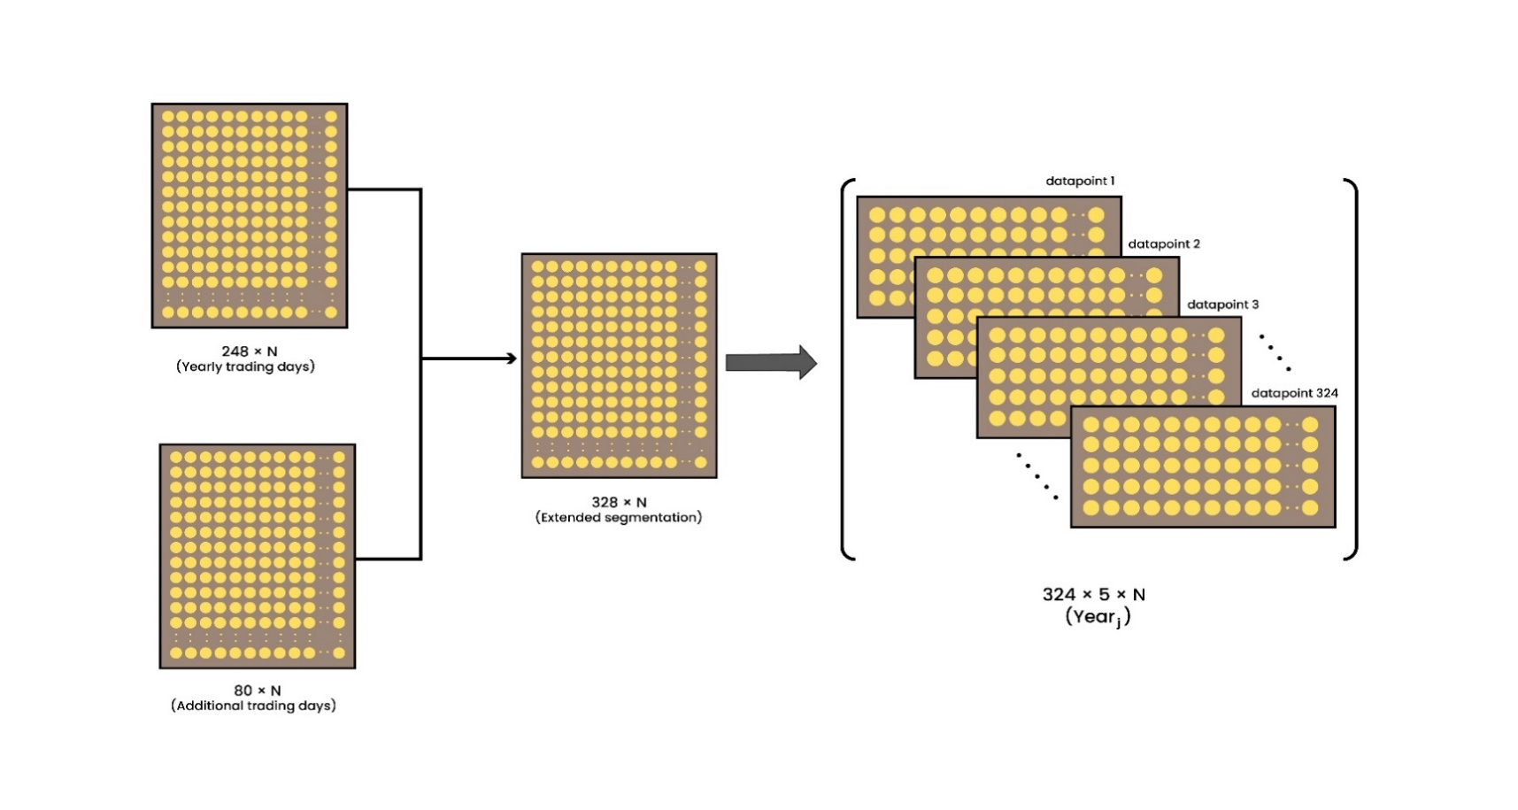
Figure 1: Dataset preparation from the stock returns in a year $j$ for model training. An extra 80 days of trading data is appended for validation purposes. As we move forward using the sliding window technique, we get 5 windows for each year.

Methodology

Normalized Logarithmic Return
Defining the daily log returns for returns $r_{i }\left(t\right)$of stock $i$ at time $t$ using the formula:
$r_{i}(t) = ln[c_{i}(t)] - ln\left[c_{i} \left(t - Δt\right)\right]$ (1)
Where, $c_{i}(t)$ is the closing price of stock $i$ on day $t$, $i = 1,…, N$ represents the index of the stock, and $t = 1,…,T$ denotes the trading day. Since we are considering only daily returns so we set, $Δt$ = 1. We utilized a one-year period to divide the data into distinct, annual subsets. It means that the complete dataset has been broken down into pieces, each of which corresponds to a distinct calendar year. After computing returns and segmentation, we normalized log returns to ensure consistent scales among stocks.
Normalization is conducted using the following formula:
$r_{i}^{'}\left(t\right)=\frac{r_{i}\left(t\right) - \left\langle r_{i}\left(t\right)\right\rangle }{σ_{i} }$ (2)
Where, $r_{i}\left(t\right)$ is the daily returns of stock $i$ at time $t$ and $<∙>$ represents the mean over one year timeframe and $σ_{i}$ represents the standard deviation of the stock $i$ over one year timeframe.

Model Construction
To capture the complex, ever-shifting relationships between stocks, we set up an LSTM Autoencoder, a specialized neural network designed to combat the vanishing gradient problem and better capture long-term dependencies. The core component is the LSTM cell initially introduced by Hochreiter et al. [34]. Unlike ordinary recurrent networks, LSTM cells keep useful facts alive across many time steps and soften, if not erase, the vanishing-gradient trouble that stymies deeper RNNs during training. LSTM unit consists of a memory cell that stores information, which is updated by three Special gates: the input gate, the forget gate and the output gate. LSTM unit structure shown in Figure 2.
Forget Gate: Forget gates decide what information to discard from the previous state, by mapping the previous state and the current input to a value between 0 and 1. If it assigns a 0, the information is discarded; if it assigns a 1, the information is kept.
Input Gate: Input gates decide which pieces of new information to store in the current cell state, using the same system as forget gates.
Output Gate: Output gates control which pieces of information in the current cell state to output, by assigning a value from 0 to 1 to the information, considering the previous and current states.

At time$t$, $x_{t}$ is the input data of the LSTM cell, $h_{t-1}$ is the output of the LSTM cell at the previous moment, $c_{t}$ is the value of the memory cell, $h_{t }$is the output of the LSTM cell. Mathematically, the operation of LSTM can be represented by following procedures:
The forget gate determines how much of the previous cell state $C_{t-1}$ should be kept or forgotten. Two inputs $x_{t}$ (input at the particular time) and $h_{t-1}$ (previous cell output) are fed to the gate and multiplied with weight matrices followed by the addition of bias. The resultant is passed through an activation function, which gives a binary output. If for a particular cell state the output is 0, the piece of information is forgotten and for output 1, the information is retained for future use. The equation for the forget gate is:
$f_{t}=σ\left(W_{f} . [h_{t-1},x_{t}]+b_{f}\right)$ (3)
Where, $W_{f}$ is the weight matrix, $b_{f}$ is the bias and $σ$ is the sigmoid activation function.
The input gate does the addition of useful information to the cell state. First, the information is regulated using the sigmoid function and filter the values to be remembered similar to the forget gate using inputs $h_{t-1}$ and $x_{t}$. The equation for the input gate is:
$i_{t}=σ\left(W_{i }.[h_{t-1},x_{t}]+b_{i}\right)$ (4)
After determining the influence of the input via the input gate, the candidate memory is calculated. This represents the potential new information to be added to the cell state. Where, $tanh$ is used to squish all values between -1 and 1, which contains all the possible values from $h_{t-1}$ and $x_{t}$.
${˜c}_{t}=tanh\left(W_{c }.[h_{t-1},x_{t}]+b_{c}\right)$ (5)
Once the forget gate and input gate are computed, the cell state is updated. The new cell state $c_{t}$is calculated by multiply the previous state by${ f}_{t}$, disregarding the information we had previously chosen to ignore. Next, we include$i_{t} ʘ {˜c}_{t}$. This represents the updated candidate values, adjusted for the amount that we chose to update each state value.
$c_{t}=f_{t} ʘ{ c}_{t-1}+i_{t} ʘ {˜c}_{t}$ (6)
Where, $ʘ$ represents elementwise multiplication.
After updating the cell state, the output gate determines how much of this updated memory should be passed on to the next time step in the form of the hidden state. The equation for the output gate is:
$o_{t}=σ\left(W_{o}.[h_{t-1},x_{t}]+b_{o}\right)$ (7)
Finally, the hidden state $h_{t}$ is updated by applying the output gate to the new cell state. This hidden state is used in the next time step and as part of the model's output.
${ h}_{t}=o_{t} ʘ{ tanh⁡(c}_{t})$ (8)
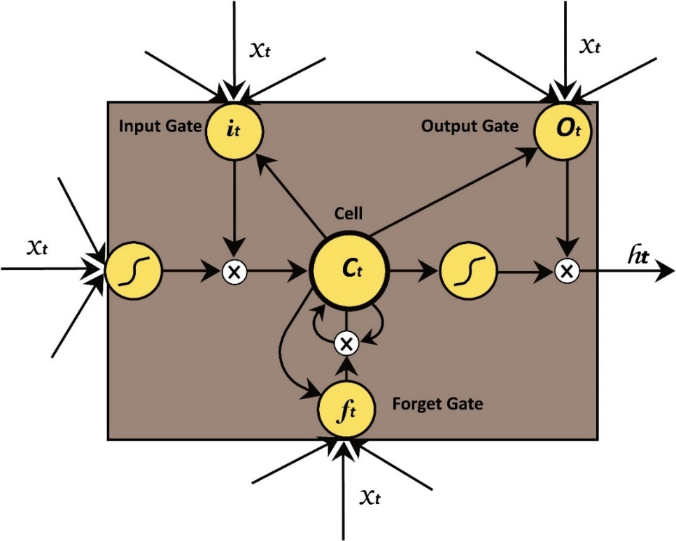

Figure 2: Architecture of an LSTM unit, illustrating the flow of information through the input gate, forget gate, and output gate. These gates regulate the cell state and hidden state to capture long-term dependencies in sequential data.
We build a task-specific LSTM Autoencoder where stacked LSTM layers make up both the encoder and the decoder. Sitting in the middle, a dense layer acts like a narrow neck and learns the connections shared across all stocks through its own weights. The model was developed using TensorFlow version 2.12.0. Figure 3 shows the comprehensive overview of the proposed LSTM Autoencoder architecture. The architecture is composed of the following elements:
Encoder:
The encoder comprises two stacked LSTM layers implemented within Time Distributed wrappers, allowing independent processing of each stock’s return sequence over a fixed-size sliding window. The first LSTM layer, with 64 units, captures temporal dependencies and extracts initial feature representations. A second LSTM layer further processes its output with 32 units, yielding a compressed encoded representation that summarizes the temporal dynamics of the input data.
Dense Layer:
A two-dimensional dense layer (referred to as Dense2D) serves as a bottleneck between the encoder and decoder. This fully connected layer integrates the encoded features across stocks, producing a weighted representation that reflects inter-stock correlations. The weight matrix in this layer is initialized using a random normal initializer, which assigns initial weight values by sampling from a Gaussian distribution centered at zero. This initialization helps break symmetry and provides a suitable starting point for training. During training, the weights of this layer learn to model latent market structures by identifying significant dependencies among stock returns.
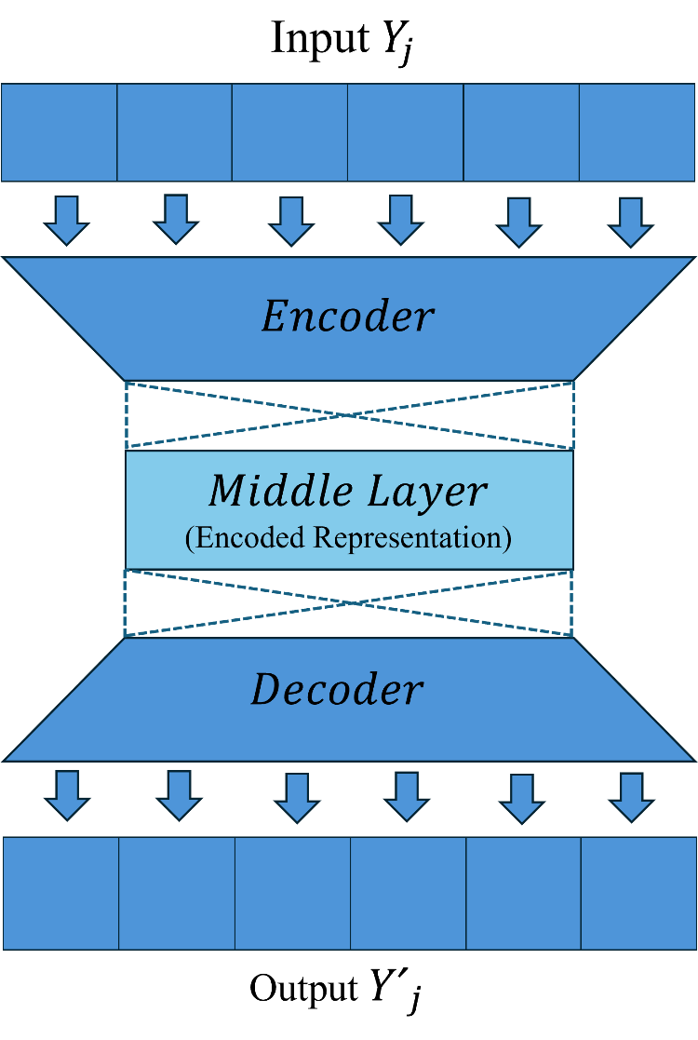
Figure 3: Comprehensive overview of the proposed LSTM Autoencoder architecture. The input sequence $Y_{j}$​ is transformed by the encoder into a compressed representation in the middle layer, which captures the essential features. The decoder then reconstructs the output sequence $Y_{j}^{'}$ from this encoded representation.
Decoder:
The decoder mirrors the encoder’s design, consisting of two stacked LSTM layers that reconstruct the input sequences from the compressed representation. The first decoder LSTM layer has 32 units and returns sequences to reconstruct temporal patterns, followed by a second LSTM layer with 64 units that further refines the output. A final Time Distributed dense layer with a single unit per time step outputs the reconstructed return values for each stock.
The model input is a four-dimensional tensor of shape (batch_size, 210, 5, 1), where 210 represents the number of stocks, 5 is the window size of consecutive trading days, and 1 denotes a single feature dimension per input element. This architecture effectively captures both temporal dependencies within each stock’s return sequence and cross-sectional relationships among stocks, providing a robust framework for modeling complex financial time series.

Model Training
To train the proposed model, we used an unsupervised learning approach. If we denote the model in year j as "${L_A_E}_{j}$", when the model reconstructs the return sequence of stock $i$ from the return sequences of all other stocks at time $t$, we can write it as follows:
$$\left(\begin{matrix}r_{i}(t) \\ r_{i}(t-1) \\ ⋮ \\ r_{i}(t-4)\end{matrix}\right)= {L_A_E}_{j}\left(\begin{matrix}r_{1}(t) & r_{2}(t) & ⋯ & r_{N}(t) \\ r_{1}(t-1) & r_{2}(t-1) & ⋯ & r_{N}(t-1) \\ ⋮ & ⋮ & ⋱ & ⋮ \\ r_{1}(t-4) & r_{2}(t-4) & ⋯ & r_{N}(t-4)\end{matrix}\right) (9)$$
$$Reconstruction Loss= \frac{1}{B*S*N}\sum_{b=1}^{B}{\sum_{s=1}^{S}{\sum_{n=1}^{N}{{{|Yʹ}_{j_{bsn}}- Y_{j_{bsn}}|}^{2} (10) }}}$$
Where B denotes the batch size i.e. the number of datapoints in a particular batch, S denotes sequence length, which is 5, N denotes total number of stocks, which is 210.${Yʹ}_{j}$ Represents model’s reconstructed output in year j, and $Y_{j}$ represents original input to the model in year k. The model iteratively learns and improves by updating its parameters in response to the reconstruction loss, which measures how well the model's predictions match the original data.

Weight Matrix Formation
After the training phase, a weight matrix $W_{k}$​ is derived from the LSTM's dense layer, which captures the interdependencies between assets based on the learned patterns. From each trained model, we extract a weight matrix $W_{k},$where each entry $W_{ij}$​ represents the influence of stock $j$ on stock $i$. In general, the matrix $W_{k}$​ can be represented as follows:
$$W_{k}=\left(\begin{aligned}W_{11} W_{12}………W_{1N} \\ W_{21} W_{22}………W_{2N} \\ \begin{matrix}. . . . \\ . . . . \\ . . . . \end{matrix} \\ W_{N1} W_{N2}………W_{NN}\end{aligned}\right) (11)$$
Importantly, The values in $W_{k}$​ are non-sequential, meaning $W_{ij}≠ W_{ji}$​, reflecting that the upper and lower triangles are not symmetric, which suggests that relationships between assets may differ in direction and magnitude.

Expected Outcomes
The primary expected outcome of this research is the development of a robust, hybrid framework that combines LSTM autoencoders and eigenvector decomposition to detect regime shift in Dhaka Stock Exchange (DSE). Specifically, we anticipate the following results:
- Early detection of regime shift in DSE market.
- Identification of structural changes in DSE during major global crises.
- Automated monitoring of regime transition of DSE index by mapping eigenvector to discrete levels.
- The framework is expected to align detected regime shifts with known prior stress in the DSE.
- The results provide actionable insights to policymakers and investors by supporting risk management, strategic decision making and policy formulation for Bangladesh.

Conclusion
This study introduces a hybrid framework that combines LSTM autoencoders with eigenvector dynamics to detect regime shifts in the Dhaka Stock Exchange (DSE). By integrating deep learning in capturing nonlinear temporal dependencies with eigenvalue based structure analysis, the framework provides more reliable method for identifying market instability. For Bangladesh, this research holds significant value. The DSE, as an emerging markets, is highly sensitive to policy changes and global economic shocks. Conventional approaches often fail to capture such complex, high dimensional dynamics. Our proposed method not only improves the ability to anticipate downturns but also strengthens the tools available to policymakers, regulators, and investors. Policymakers of Bangladesh can leverage these insights for more effective crisis management and regulatory reforms and decision making. Beyond regime detection, it can encourage investor confidence, promote market transparency, and ultimately foster suitable growth of Bangladesh’s capital market.

References

[1] T. E. Rozhdestvenskaya and A. G. Guznov, ‘Financial market’, Общенациональный интерактивный энциклопедический портал ‘Знания’, no. 12, 2022, doi: 10.54972/00000001_2022_12_31.
[2] J. Greenwood and B. D. Smith, ‘Financial markets in development, and the development of financial markets’, J Econ Dyn Control, vol. 21, no. 1, pp. 145–181, Jan. 1997, doi: 10.1016/0165-1889(95)00928-0.
[3] M. H. A. Davis, ‘1. Money, banking, and financial markets’, in Mathematical Finance: A Very Short Introduction, Oxford University Press, 2019, pp. 1–11. doi: 10.1093/actrade/9780198787945.003.0001.
[4] T. Preis, D. Y. Kenett, H. E. Stanley, D. Helbing, and E. Ben-Jacob, ‘Quantifying the Behavior of Stock Correlations Under Market Stress’, Sci Rep, vol. 2, no. 1, p. 752, Oct. 2012, doi: 10.1038/srep00752.
[5] D. Sornette, Why Stock Markets Crash. Princeton: Princeton University Press, 2009. doi: 10.1515/9781400829552.
[6] J. Cao, Z. Li, and J. Li, ‘Financial time series forecasting model based on CEEMDAN and LSTM’, Physica A: Statistical Mechanics and its Applications, vol. 519, pp. 127–139, Apr. 2019, doi: 10.1016/j.physa.2018.11.061.
[7] T. Fischer and C. Krauss, ‘Deep learning with long short-term memory networks for financial market predictions’, Eur J Oper Res, vol. 270, no. 2, pp. 654–669, Oct. 2018, doi: 10.1016/j.ejor.2017.11.054.
[8] A. Angabini and S. Wasiuzzama, ‘GARCH Models and the Financial Crisis-A Study of the Malaysian Stock Market’, The International Journal of Applied Economics and Finance, vol. 5, no. 3, pp. 226–236, Mar. 2011, doi: 10.3923/IJAEF.2011.226.236.
[9] T. Mikosch, ‘CHANGES OF STRUCTURE IN FINANCIAL TIME SERIES AND THE GARCH MODEL C˘ at˘ alin St˘ aric˘ a’, REVSTAT-Statistical Journal, vol. 2, no. 1, 2004.
[10] J.-P. Bouchaud and M. Potters, ‘Financial applications of random matrix theory: a short review’, in The Oxford Handbook of Random Matrix Theory, G. Akemann, J. Baik, and P. Di Francesco, Eds., Oxford University Press, 2015, pp. 823–850. doi: 10.1093/oxfordhb/9780198744191.013.40.
[11] M. Potters, J.-P. Bouchaud, and L. Laloux, ‘Financial Applications of Random Matrix Theory: Old Laces and New Pieces’, 2015.
[12] X. F. Jiang and B. Zheng, ‘Anti-correlation and subsector structure in financial systems’, Europhys Lett, vol. 97, no. 4, p. 48006, Feb. 2012, doi: 10.1209/0295-5075/97/48006.
[13] J. Shen and B. Zheng, ‘Cross-correlation in financial dynamics’, EPL, vol. 86, no. 4, Feb. 2012, doi: 10.1209/0295-5075/86/48005.
[14] V. Plerou, P. Gopikrishnan, B. Rosenow, L. A. N. Amaral, T. Guhr, and H. E. Stanley, ‘Random matrix approach to cross correlations in financial data’, Phys Rev E, vol. 65, no. 6, p. 066126, Jun. 2002, doi: 10.1103/PhysRevE.65.066126.
[15] Z. Zheng, B. Podobnik, L. Feng, and B. Li, ‘Changes in Cross-Correlations as an Indicator for Systemic Risk’, Scientific Reports 2012 2:1, vol. 2, no. 1, pp. 1–8, Nov. 2012, doi: 10.1038/srep00888.
[16] J. Jurczyk, T. Rehberg, A. Eckrot, and I. Morgenstern, ‘Measuring critical transitions in financial markets’, Sci Rep, vol. 7, no. 1, p. 11564, Sep. 2017, doi: 10.1038/s41598-017-11854-1.
[17] M. Billio, M. Getmansky, A. W. Lo, and L. Pelizzon, ‘Measuring Systemic Risk in the Finance and Insurance Sectors Measuring Systemic Risk in the Finance and Insurance Sectors *’. [Online]. Available: http://ssrn.com/abstract=1573902
[18] X. Zhao, P. Shang, and J. Huang, ‘Mutual-information matrix analysis for nonlinear interactions of multivariate time series’, Nonlinear Dyn, vol. 88, no. 1, pp. 477–487, Apr. 2017, doi: 10.1007/s11071-016-3254-7.
[19] Y. C. Gao, R. Tan, C. J. Fu, and S. M. Cai, ‘Revealing stock market risk from information flow based on transfer entropy: The case of Chinese A-shares’, Physica A: Statistical Mechanics and its Applications, vol. 624, Aug. 2023, doi: 10.1016/J.PHYSA.2023.128982.
[20] J. He and P. Shang, ‘Comparison of transfer entropy methods for financial time series’, Physica A: Statistical Mechanics and its Applications, vol. 482, pp. 772–785, Sep. 2017, doi: 10.1016/J.PHYSA.2017.04.089.
[21] W. Chen, Y. Wei, Q. Lang, Y. Lin, and M. Liu, ‘Financial market volatility and contagion effect: A copula-multifractal volatility approach’, Physica A: Statistical Mechanics and its Applications, vol. 398, pp. 289–300, Mar. 2014, doi: 10.1016/j.physa.2013.12.016.
[22] X. Wen, Y. Wei, and D. Huang, ‘Measuring contagion between energy market and stock market during financial crisis: A copula approach’, Energy Econ, vol. 34, no. 5, pp. 1435–1446, Sep. 2012, doi: 10.1016/j.eneco.2012.06.021.
[23] S. An, X. Gao, F. An, and T. Wu, ‘Early warning of regime switching in a complex financial system from a spillover network dynamic perspective’, iScience, vol. 28, no. 3, p. 111924, Mar. 2025, doi: 10.1016/J.ISCI.2025.111924.
[24] A. L. Suárez-Cetrulo, D. Quintana, and A. Cervantes, ‘Machine Learning for Financial Prediction Under Regime Change Using Technical Analysis: A Systematic Review’, International Journal of Interactive Multimedia and Artificial Intelligence, vol. In press, no. In press, p. 1, 2023, doi: 10.9781/ijimai.2023.06.003.
[25] L. de Prado, ‘Praise for Advances in Financial Machine Learning’, 2018.
[26] M. C. Münnix et al., ‘Identifying states of a financial market’, Sci Rep, vol. 2, 2012, doi: 10.1038/srep00644.
[27] V. I. Kontopoulou, A. D. Panagopoulos, I. Kakkos, and G. K. Matsopoulos, ‘A Review of ARIMA vs. Machine Learning Approaches for Time Series Forecasting in Data Driven Networks’, Future Internet 2023, Vol. 15, Page 255, vol. 15, no. 8, p. 255, Jul. 2023, doi: 10.3390/FI15080255.
[28] R. Alam, R. I. Arnob, and A. E. Alam, ‘An ARIMA-LSTM Correlation Coefficient Based Hybrid Model for Portfolio Management of Dhaka Stock Exchange’, 2020, pp. 214–226. doi: 10.1007/978-3-030-60036-5_15.
[29] K. H. Tuhin, A. Nobi, M. H. Rakib, and J. W. Lee, ‘Long short-term memory autoencoder based network of financial indices’, Palgrave Commun, vol. 12, no. 1, pp. 1–15, Dec. 2025, doi: 10.1057/S41599-025-04412-Y.
[30] A. Sagheer and M. Kotb, ‘Unsupervised Pre-training of a Deep LSTM-based Stacked Autoencoder for Multivariate Time Series Forecasting Problems’, Scientific Reports 2019 9:1, vol. 9, no. 1, pp. 1–16, Dec. 2019, doi: 10.1038/s41598-019-55320-6.
[31] K. Wang, ‘Multifactor prediction model for stock market analysis based on deep learning techniques’, Scientific Reports 2025 15:1, vol. 15, no. 1, pp. 1–20, Feb. 2025, doi: 10.1038/s41598-025-88734-6.
[32] D. Gorduza, X. Dong, and S. Zohren, ‘Understanding stock market instability via graph auto-encoders’, Dec. 2022, doi: 10.1140/EPJDS/S13688-025-00523-3.
[33] “Investing.com - Stock Market Quotes & Financial News.” Accessed: Aug. 28, 2025. [Online]. Available: https://www.investing.com/
[34] S. Hochreiter and J. Schmidhuber, ‘Long Short-Term Memory’, Neural Comput, vol. 9, no. 8, pp. 1735–1780, Nov. 1997, doi: 10.1162/neco.1997.9.8.1735.

